CHAPTER 1

ANNEX I

***Operationalizing the Typology of Small Farm Households***

Prepared by Peter Hazell, Stanley Wood, Bhramar Dey, and Melanie Bacou

This annex aims to show how the small farm typology described in this chapter can be operationalized to segment farms in practice. It uses household survey data to classify farms and quantify their relative importance and household characteristics, and spatial mapping techniques to identify geographic areas where the different types of households are likely to be concentrated.

The analysis uses recent household survey data from Ghana (Ghana Living Standard Survey 2012/2013), Ethiopia (Ethiopia Socioeconomic Survey 2015/2016) and Tanzania (Tanzania National Panel Survey 2012/2013) to demonstrate the approach.[1] Data on the share of crop production sold, and the share of nonfarm income in total income, are used to segment the households into the five groups described in Table 1 of the chapter. Small farms are defined as having 4 ha or less of agricultural land. Common boundary value choices between the different nonfarm income share and crop sale share segments were determined iteratively through cross-country comparison, leading to the results in Table A.1.

Table A.1: Composition of small farms ≤ 4 ha by type of livelihood strategy, Ghana, Ethiopia and Tanzania

|  |  |  |  |
| --- | --- | --- | --- |
| Nonfarm income  as share of total household income | Share of crop production sold | | |
| Low  (≤ 5%) | Medium  (5-50%) | High  (>50%) |
| *Ghana, GLSS 2012-13 (sample size 7,743)* | | | |
| Low (≤ 33%) | 8.1 | 14.5 | 22.6 |
| High (>33%) | 38.9 | | 15.9 |
| *Ethiopia, ESS 2013-14 (sample size 3,000)* | | | |
| Low (≤ 33%) | 17.2 | 32.0 | 6.8 |
| High (>33%) | 39.4 | | 4.6 |
| *Tanzania, NPS 2012-13 (sample size 2,855)* | | | |
| Low (≤ 33%) | 5.1 | 15.8 | 14.6 |
| High (>33%) | 49.9 | | 14.6 |

Source: Authors’ calculations using nationally representative household survey data. Estimates are representative for the sub-population of farms below 4 ha. Income and sales estimates are derived from FAO Rural Income Generating Activities (RIGA) database.

Commercial small farms are defined as selling 50% or more of their production. They are further subdivided into specialized commercial farms if their nonfarm income share is less than 33%, and diversified commercial farms otherwise. Taken together, about 30-40 percent of all small farms are commercial in Ghana and Tanzania, but only about 12 percent in Ethiopia (the sum of the yellow and green cells in Table A.1). There are about as many specialized (yellow cells) as diversified (green cells) commercial small farms in Ethiopia and Tanzania, but more specialized than diversified commercial farms in Ghana.

Pre-commercial small farms are defined as selling 5-50% of their production, and earning less than 33% of their income from nonfarm sources. They account for about 15% of all small farms in Ghana and Tanzania and 32% in Ethiopia (the blue cells in Table A.1).

Transition farms (the pink cells in Table A.1) obtain 33% or more of their income from nonfarm sources and sell up to 50% of their crop output. They are the largest group, accounting for 38.9% of all small farms in Ghana, 39.4% in Ethiopia, and 49.9% in Tanzania.

Subsistence oriented small farms are defined as selling less than 5% of their agricultural output and obtaining less than 33% of their total income from nonfarm sources (the red cells in Table A.1). They are a relatively small group, accounting for less than 10 percent of all small farms in Tanzania and Ghana, and 17 percent in Ethiopia.

The same data sources were used to characterize the different types of households in each country (Table A.2). There is a clear bimodality in the distribution of nonfarm income shares, with transition and diversified commercial farms receiving very high shares of nonfarm income in all three countries, while the other groups receive hardly any. The households that are diversified into nonfarm sources of income also have by far the highest total incomes. The pattern is the same in all three countries: diversified commercial farmers have the highest income of all, followed by transition households, specialized commercial farms rank a poor third, followed by pre-commercial farmers, and then subsistence farmers who are by far the poorest. Although not shown in the table, there is little difference in the household size amongst the five groups, or in the number of adult workers, or the age of the head. However, there are differences in holding size, though there is little obvious relationship between nonfarm income shares and farm size, and commercial farms are not noticeably bigger. Commercial and transition farms have better educated household heads than average, and in Ethiopia and Tanzania, are more likely to be male headed. In Ethiopia, for example, 20.5% of the heads of subsistence farms are women, compared to 8.6% for diversified commercial farms, and 12.2% for specialized commercial farms.

Table A.2: Summary statistics for different segments of farm households

|  |  |  |  |  |  |  |  |  |
| --- | --- | --- | --- | --- | --- | --- | --- | --- |
|  | Farm Household Type | | | | | | | |
| Subsistence | Pre-commercial | | Commercial  specialized | Transition | Commercial diversified | Average |
| *% Nonfarm income* | | | | | | | | |
| Ghana | 2.2 | 3.3 | 4.0 | | 92.5 | 82.3 | 42.9 |
| Ethiopia | 3.5 | 4.0 | 2.4 | | 81.4 | 82.7 | 38.2 |
| Tanzania | 3.9 | 6.9 | 7.7 | | 87.2 | 71.8 | 56.3 |
| *% Cash sales* | | | | | | | | |
| Ghana | 0.3 | 29.6 | 76.6 | | 7.7 | 78.6 | 43.6 |
| Ethiopia | 1.2 | 20.2 | 70.0 | | 10.9 | 72.9 | 19.2 |
| Tanzania | 0.3 | 28.1 | 73.4 | | 12.5 | 76.4 | 32.6 |
| *Mean income as ratio of subsistence household income* | | | | | | | | |
| Ghana | 1.0 | 1.9 | 2.7 | | 37.5 | 41.3 |  |
| Ethiopia | 1.0 | 1.9 | 2.6 | | 34.3 | 42.1 | 16.5 |
| Tanzania | 1.0 | 1.7 | 3.9 | | 9.7 | 18.7 | 8.5 |
| *Farm size (ha)* | | | | | | | | |
| Ghana | 0.80 | 1.10 | 1.30 | | 1.00 | 1.10 | 1.10 |
| Ethiopia | 1.52 | 1.74 | 0.83 | | 1.18 | 0.58 | 1.36 |
| Tanzania | 3.10 | 3.40 | 3.28 | | 3.35 | 2.54 | 2.72 |
| *Education of household head (years)* | | | | | | | | |
| Ghana | 3.10 | 3.60 | 4.10 | | 5.60 | 5.80 | 4.50 |
| Ethiopia | 1.46 | 1.71 | 1.82 | | 1.77 | 3.28 | 1.77 |
| Tanzania | 3.27 | 4.10 | 4.89 | | 4.93 | 5.99 | 4.86 |
| *% Female headed households* | | | | | | | | |
| Ghana | 30.1 | 20.9 | 20.7 | | 33.6 | 26.2 | 27.1 |
| Ethiopia | 20.5 | 17.4 | 12.2 | | 22.2 | 8.6 | 19.1 |
| Tanzania | 32.1 | 22.8 | 17.0 | | 31.7 | 16.9 | 26.0 |
| Distance to road (km) | | | | | | | | |
| Ghana | 1.6 | 1.2 | 0.9 | | 0.3 | 0.3 | 0.7 |
| Ethiopia |  |  |  | |  |  |  |
| Tanzania |  |  |  | |  |  |  |

Source: Authors’ calculations using the nationally representative household survey data.

A helpful feature of the typology in Table A.1 is that it has an implicit spatial dimension. Commercial farming is more likely to be found in areas with good agricultural potential; quick access to urban markets may also be important, especially for the production of high value but perishable commodities. Nonfarm income earning opportunities for diversifying household income are more likely in areas with good access to roads and urban centers. Subsistence farmers might be expected to concentrate in less favored areas with poor agricultural potential and poor market access. Since agricultural potential and access to markets and urban centers can be mapped, it is possible to use spatially-referenced data on these variables to identify geographic areas where different types of small farms are likely to be concentrated.

The approach is illustrated in Figure A.1 for Tanzania. Here the country has been segmented into spatial units by overlaying maps of agricultural potential with time of travel to a marketing center with at least 100,000 people. Agricultural potential is assessed as suitability for rainfed farming using data on soils, temperature and rainfall. For simplicity, only two categories (low and high) are used for each segmenting variable, and this leads to four types of segments: lo-lo, lo-hi, hi-lo, and hi-hi, in terms of agricultural potential and market access, respectively.

More refined analysis is of course possible, but even this coarse level of spatial segmentation shows some interesting relationships in terms of locating different types of small farms. Table A.3 cross-tabulates the percentage of each of the five small farm types against four spatial segments. We do not attempt to map the households to individual spatial units on the map because the sample sizes are too small. But, even at an aggregate level, some patterns can be observed. For example, pre-commercial farms are more concentrated in areas of low market access and low agricultural potential (LoLo) and in HiLo areas, suggesting that they are being held back from becoming more successful commercial farms by poor market access, and sometimes also by agricultural potential. Specialized commercial farms are more concentrated in HiLo areas, suggesting that market access may be a constraint for them too. Surprisingly, few specialized commercial farmers are concentrated in the HiHi spatial segment, seemingly because in those areas with good access to urban nonfarm opportunities they either become diversified commercial farms or transition households. Subsistence farmers are more concentrated in LoHi and HiLo areas, but are also well represented in the other spatial segments too. It would seem that factors other than agricultural potential and urban access are helping to keep these households poor. Much richer results can be expected with more disaggregated levels of spatial definition, and by mapping households into spatial units at regional rather than national levels. This work is ongoing for Tanzania and several other African countries, and could be used as aid in targeting future development assistance to small farms.

Within specific geographic areas, further disaggregation of households is possible using survey data and local knowledge. The private sector, for example, already uses local knowledge to identify farmers with whom it can do business, and many NGO and social protection agencies are experienced at selecting poor and women farmers for inclusion in their development/protection projects. However, NGOs and the public sector are less experienced in identifying areas and farmers who are best served by a farm business approach.

References

Carletto, G., Covarrubias, K., Davis, B., Krausova, M., & Winters, P. (2007). Rural Income Generating Activities Study: Methodological note on the construction of income aggregates. Rural Income Generating Activities (RIGA) Project. Food and Agriculture Organization (FAO). Retrieved from <http://www.fao.org/fileadmin/user_upload/riga/pdf/ai197e00.pdf>

Central Statistical Agency of Ethiopia (2017) LSMS-Integrated Surveys on Agriculture, Ethiopia Socioeconomic Survey (ESS), 2015/2016. Retrieved from <http://microdata.worldbank.org/index.php/catalog/2783.>

Ghana Statistical Service (2014) Ghana Living Standards Survey Round 6 (GLSS6) Main Report. Retrieved from http://www.statsghana.gov.gh/docfiles/glss6/GLSS6_Main%20Report.pdf.

FAO. (2016). Components of Income Aggregate: Ghana General Living Standards Survey 2012-2013. Rural Income Generating Activities (RIGA) Project. Food and Agriculture Organization (FAO). Retrieved from http://www.fao.org/economic/riga/riga-database/riga-survey/en/

HarvestChoice, International Food Policy Research Institute (IFPRI); University of Minnesota, 2016, "CELL5M: A Multidisciplinary Geospatial Database for Africa South of the Sahara", doi:10.7910/DVN/G4TBLF, Harvard Dataverse, V3

HarvestChoice; International Food Policy Research Institute (IFPRI), 2016, "Travel Time to Markets in Africa South of the Sahara", doi:10.7910/DVN/YKDWJD, Harvard Dataverse, V2

National Bureau of Statistics (2014) Tanzania National Panel Survey Wave 3, 2012-2013. Ministry of Finance, Retrieved from <http://microdata.worldbank.org/index.php/catalog/2252.>

**Figure A.1: Map of agricultural development domains for Tanzania**

**Delineation of Sub-national Agricultural Development Segments**

The map shows a spatial representation of sub-national areas in Tanzania that exhibit important differences in their suitability for rainfed agriculture and their distance from larger human settlements (i.e. major markets and service centers). The legend shows 4 [2 x 2] classes of the combination of hi / lo rainfed agriculture potential and hi / lo distance to markets (travel time to settlements of at least 100.000 people) indicating the agricultural potential first. This map also limits its depiction of the 2x2 areas to those locations known to lie within the major cropland areas of Tanzania, as assessed by analysis of satellite imagery coupled with ground validation (AfSIS 2016).

Within the geographic extent of each segment (see map) the nature of agricultural development constraints as well as the potential impact of specific types of intervention are likely to be more similar than between different segments. This type of mapping can thus be helpful in the geographic targeting of specific types of intervention.

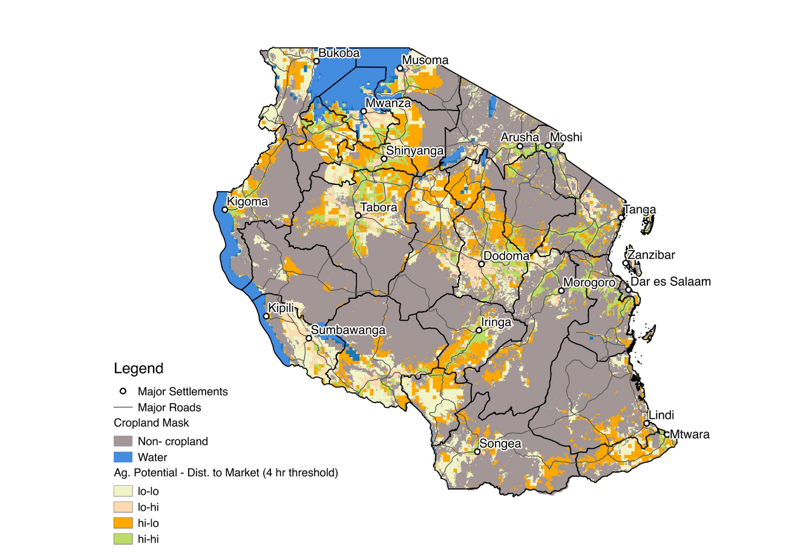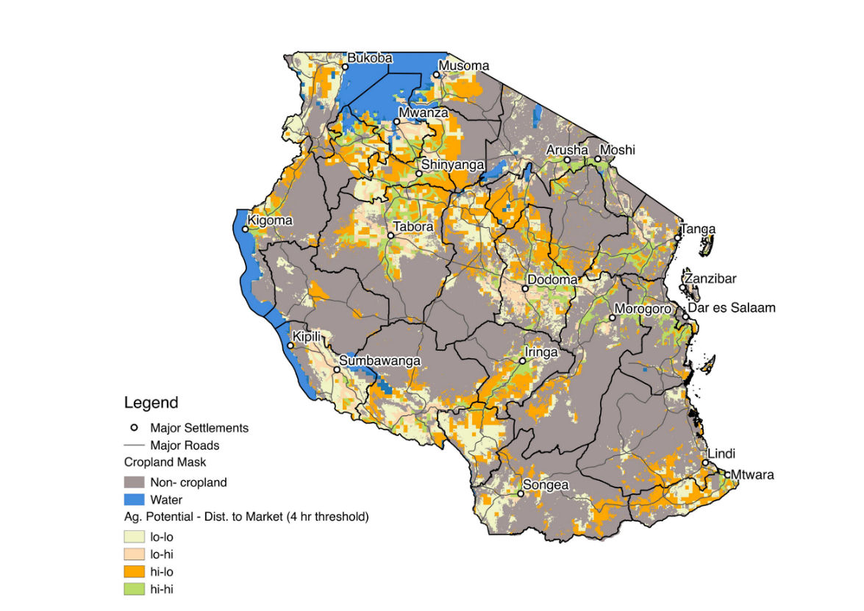

Table A.3: Distribution of household types by development domain, Tanzania

|  |  |  |  |  |  |  |
| --- | --- | --- | --- | --- | --- | --- |
| Develop-  ment  domain | Type household | | | | | |
| Subsistence | Pre-commercial | Commercial  specialized | Transition | Commercial diversified | Total |
| LoLo | 20.0 | 34.5 | 21.7 | 23.2 | 26.6 | 24.6 |
| LoHi | 27.3 | 16.2 | 17.5 | 14.9 | 16.8 | 16.4 |
| HiLo | 27.9 | 32.1 | 40.9 | 28.6 | 28.3 | 30.9 |
| HiHi | 24.8 | 20.2 | 19.9 | 33.2 | 28.2 | 28.0 |
| Total | 100 | 100 | 100 | 100 | 100 | 100 |

Note: Domains defined by agricultural potential and distance to market (4 hour threshold). LoHi means low agricultural potential and high market access.

Source: Authors’ calculations from NPS survey, AfSIS crop mask (2016) and HarvestChoice agricultural potential and market access geospatial variables (2015).

1. Ethiopia and Tanzania surveys are national instances of the World Bank supported Living Standards Measurement Study – Integrated Survey on Agriculture, LSMS-ISA.